# ASR 6988

* ASR 6988 for adding shipping document codes to Packing list, Delivery Order, Loading Plan report

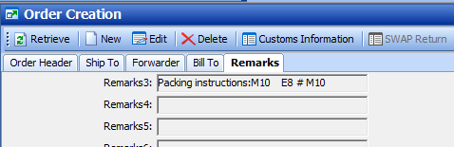

, Packing_Instructions = dbo.fn_of_Sony_GetShippingInstruction ('Packing instructions' , MAX(Orderkey) )

#Tech note:

Packing list and Delivery order – using same SP: SCH_Sony_PackingList_DO_Report

## Packing List

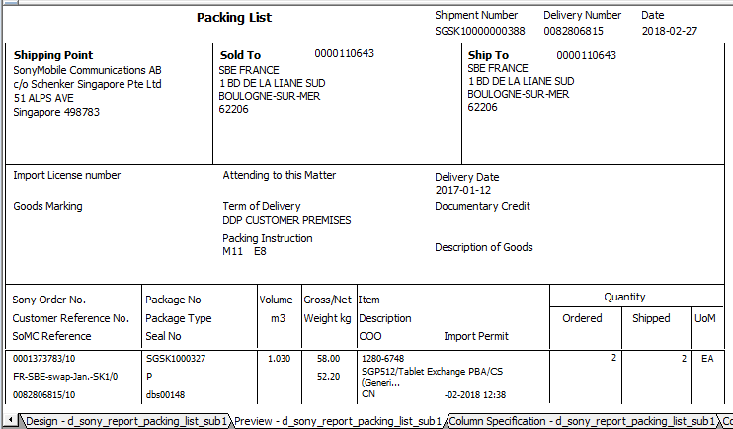

## Delivery Order

#tech note: SP: SCH_Sony_PackingList_DO_Report

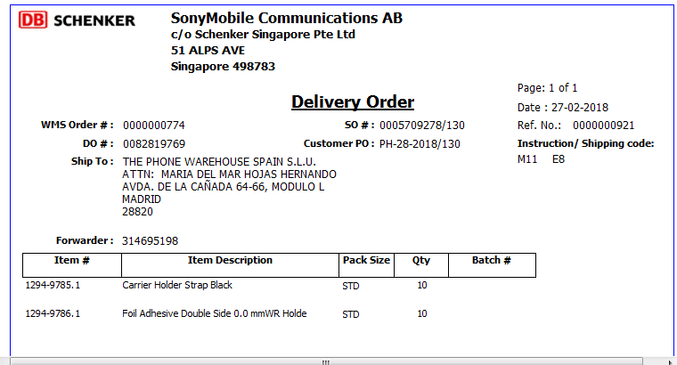

## Loading Report

